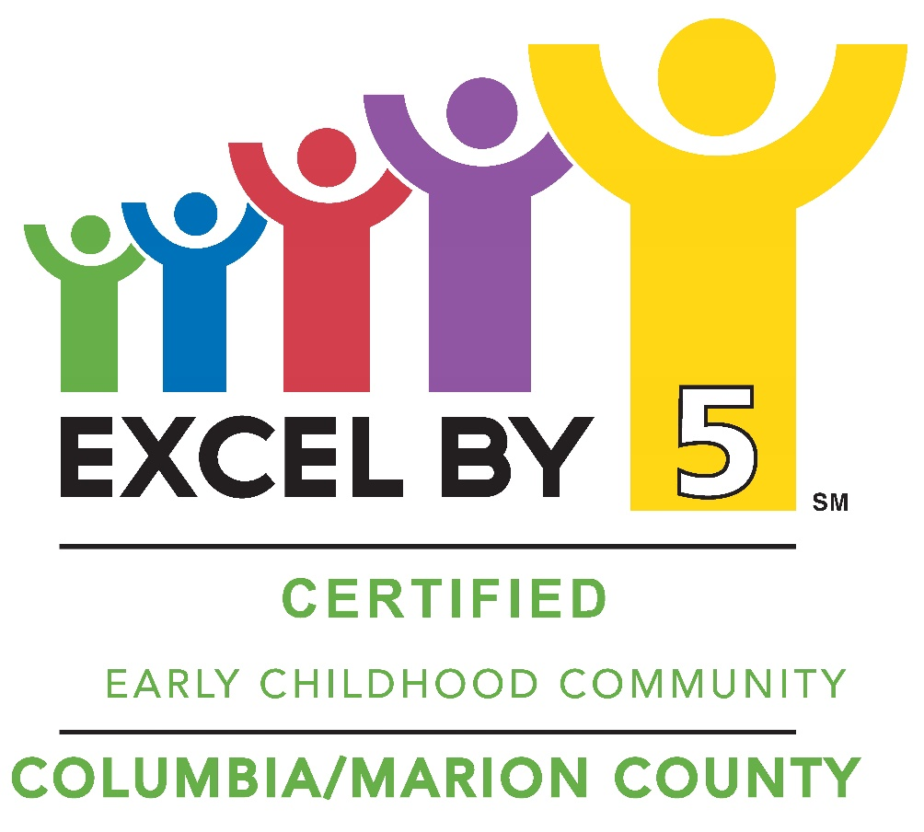

Family Resource Directory

Table of Contents

Quick Reference Guide……………………………………………3
Abuse/Neglect……………………………………………………… 4
Alcohol/Drug Abuse - Support………………………………….. 5
Child Care - Licensed Centers………………………………….. 6
City of Columbia—Departments………………………………… 7
Counseling/Mental Health……………………………………….. 8
Education
Colleges/Universities………………………………………...11
Pre-K/HeadStart……………………………….......................12
Columbia School District…………………………………….13
Marion County School District..…………………………….14
Private…………………………………………………………...15
Employment Assistance………………………………………... .15
Family Services…………………………………………………... .16
Food………………………………………………………………… .17
Health Services
Dental…………………………………………………………...18
Hospitals/Clinics……………………………………………...19
Insurance……………………………………………………….20
Pharmacy……………………………………………………….20
Vision……………………………………………………………20
Housing Assistance/Repair……………………………………. 23
Legal Assistance…………………………………………………. 26
Library..……………………………………………………………. 26
Parks and Recreation……………………………………………. 27
Pregnancy/Childbirth……………………………………………. 29
Senior Services…………………………………………………… 30
Social Services…………………………………………………… 31
Special Needs…………………………………………………….. 33
Transportation……………………………………………………. 34
Utilities……………………………………………………………... 35
Youth Services…………………………………………………….36

Quick Reference Guide
Need help? Mississippi 2-1-1
2-1-1 connects people with local community resources like emergency food, clothing, housing, job services, and counseling.

To report child abuse:
Call MS Centralized Intake - Child Abuse Hotline
1-800-222-8000
https://reportabuse.mdcps.ms.gov/

Columbia Fire Department:
Dial 9 -1-1 for emergencies.
601-736-4556
801 Pearl Street
Columbia, MS 39429

Marion General Hospital
601-736-6303
1560 Sumrall Road,
Columbia, MS 39429

Poison Control
1-800-222-1222

Columbia Police Department
Dial 9 -1 - 1 for emergencies.
601-736-8225
205 Second Street
Columbia, MS 39429

Marion County Sheriff’s Department
601-736-2711
219 Broad Street
Columbia, MS 39429

Abuse/Neglect

To report child abuse:
MS Centralized Intake/Child Abuse Hotline
1-800-222-8000
https://reportabuse.mdcps.ms.gov/

Domestic Abuse Family Shelter
Laurel, MS
Crisis: 1-800-649-1092
Admin: 601-428-1707
www.dafsms.org
Counties Served: Covington, Forrest, Greene, Jasper, Jefferson Davis, Jones, Lamar, Marion, Perry, Smith, Wayne
Services:
Emergency Shelter • Childcare • Advocacy Services • Batterer Intervention Program • 24-Hour Crisis Line • Residential Counseling • Non-Residential Counseling • Emergency Transportation • Community Education • Referral Services

Kids Hub Child Advocacy Center
601-505-5800
https://www.kidshubms.com
didi.ellis@kidshubms.com

Provides forensic interviews, family and victim advocacy, child abuse prevention education within the community and multidisciplinary team case review.

Shafer Center for Crisis Intervention
601-264-7777
507 N. 37th Avenue
Hattiesburg, MS 39401
www.theshafercenter.info

Serves all survivors of sexual violence and co-victims of violent death, including homicide and suicide, at any point following their experience through direct services, advocacy, education, training and activism.

Alcohol/Drug Abuse – Support

Al-Anon (for family members and friends of alcoholics)
Chapel Of The Cross First Methodist Church (Upstairs. third door on right Group ID 53868)
1639 Highway 99 East
Columbia, MS 39429
Tuesday at 7:00 a.m.

Alcoholics Anonymous
720 Main Street (Tower Loans, 2nd Floor)
Columbia, MS 39429
Tuesday & Friday at 7:00 p.m.; Sunday at 8:00 a.m.

Narcotics Anonymous
312 Honey Alley
Columbia, MS 39429
Monday, Tuesday, Thursday, an Saturdays at 7:00 p.m.

Pine Belt Mental Healthcare Resources
217 Dewey Street
Columbia, MS 39429
601-7366799
www.pbmhr.org

Child Care - Licensed Centers

Columbia Presbyterian Preschool
601-736-4444
500 Church Street
Columbia, MS 39429

First Baptist Day Care
601-736-4914
900 High School Avenue
Columbia, MS 39429

Kurious Little Hands
601-297-7326
134 Garner Circle Drive
Columbia, MS 39429

Little Foxworth Preschool
601-
2216 Highway 586
Foxworth, MS 39483

Little People’s Creative Learning
601-633-5150
300 S Main Street
Columbia, MS 39429

My Luv Childcare Center
601-731-2090
904 Church Street
Columbia, MS 39429

My Luv Childcare Center II
601-736-8326
1470 Highway 13 S
Columbia, MS 39429

Tender Loving Care
601-731-1098
4 Lakeview Road
Columbia, MS 39429

Woodlawn Child Care
601-736-4122
1452 Highway 98 E
Columbia, MS 39429

City of Columbia - Departments

Animal Control
601-731-2991
177 Airport Road

City Hall
www.cityofcolumbiams.com
601-736-8201
201 Second Street

Civil Defense
601-736-9627
Courthouse Square

Fire Department
601-736-4556
801 Pearl Street

Police Department
601-736-8225
201 Second Street

Water Department
601-736-8201

Counseling/Mental Health
Canopy Children’s Solutions
601-264-7079
120 Plaza Drive
Hattiesburg, MS 39402
www.mycanopy.org
Home & community-based program (MYPAC) that provides treatment for youth with Serious Emotional Disturbance (SED) with same level of care as residential treatment.

Community Counseling and Assessment Clinic
601-266-4601
USMwww.usm.edu/counseling-psychology-clinic
Student-run clinic offers psychology assessment services and counseling on a sliding fee scale.

NOOL Counseling
601-606-0561
604 Adeline St., Ste. B
Hattiesburg, MS
www.noolcounseling.com
Counseling center that accepts Medicaid.

Personal Growth Center
601-584-9540
1003 W Pine Street
Hattiesburg, MS 39401
Counseling center that accepts Medicaid.

Pine Belt Mental Healthcare Resources
217 Dewey Street
Columbia, MS 39429
601-7366799
www.pbmhr.org
Pine Belt offers a variety of behavioral health services designed to help children, adolescents and their families. Pine Belt’s Adult Outpatient Programs serve individuals with mental health, substance abuse, and co-occurring mental and substance abuse disorders.

Pine Grove Behavioral Health
1-888-574-HOPE (4673)
2255 Broadway Drive
Hattiesburg, MS 39401
www.pinegrovetreatment.com
Behavioral health and addiction services. Inpatient, outpatient, and residential treatment.

Shafer Center for Crisis Intervention
601-264-7777
507 N. 37th Ave
Hattiesburg, MS 39401
www.theshafercenter.info
Serves all survivors of sexual violence and co-victims of violent death, including homicide and suicide.

Sycamore Tree Counseling Services
601-545-2442
207 3rd Ave
Hattiesburg, MS 39401
Accepts Medicaid

USM Clinic for Family Therapy
601-266-5475
3502 Morningside Drive
Hattiesburg, MS 39401
Provides counseling for individuals, couples, family problems, and parenting issues. Fees based on a sliding scale.

Will’s Way
601-255-5264
32 Millbranch Rd #40
Hattiesburg, MS 39402
www.willswaybehavioral.com
A pediatric psychology practice offering behavioral consultation and treatment for children and their families.

Your Family Clinic
601-544-8935
514 Old Richton Rd
Petal, MS 39465
www.yourfamilyclinic.com
Psychologist accepting Medicaid and private insurance.

Education
PRCC GED Prep Classes & Testing
601-403-1810
http://www.prcc.edu/ged
Carl Loftin Vo-Tech Center
Highway 13 South
Wednesday at 1:30 pm; To schedule an orientation appointment, call (601) 403-1439.

Youth Challenge Academy @ Camp Shelby
601-558-2300
www.msyouthchallenge.org
5-month residential military program for ages 16-18.

Education – College
Jones County Junior College
601-477-4000
900 South Court St
Ellisville, MS 39437
www.jcjc.edu

Pearl River Community College
601-403-1000
101 Highway 11 North
Poplarville, MS 39470
www.prcc.edu

PRCC Forrest County Campus
601-554-5555
5448 Highway 49
Hattiesburg, MS 39401
www.prcc.edu

University of Southern MS
601-266-1000
118 College Drive
Hattiesburg, MS 39406
www.usm.edu

William Carey University
601-318-6051
710 William Carey Parkway
Hattiesburg, MS 39401
www.wmcarey.edu

Education – Pre-K/Head Start
Marion County & Columbia Early Learning Collaborative (K-4)
601-736-7193
Sites served: MAP Head Start, Columbia Primary School, East Marion Elementary, West Marion Primary, My Luv Child Care Center, and Little Foxworth Preschool.

MAP Head Start
601-923-4100
800-924-4615
1751 Morson Road
Jackson, MS 39209

Columbia Head Start Center
601-522-2948
Columbia Primary School
501 Dale Street
Columbia, MS 39429

East Marion Head Start Center
601-736-7290
East Marion Elementary School
527 East Marion School Rd
Columbia, MS 39429

Hub Head Start Center
601-731-3779
431 Old Highway 13 South
Columbia, MS 39429

West Marion Head Start Center
601-736-3713
West Marion Primary School
20 Cedar Hill Rd.
Foxworth, MS 39483

Education – Columbia School District
Superintendent’s Office
601-736-2366
613 Wildcat Way

Columbia Primary School
601-736-7666
913 West Avenue
Grades Pre-K, K, 1, 2

Columbia Elementary School
601-736-2362
401 Mary Street
Grades 3, 4, 5

Jefferson Middle School
601-736-2786
611 Owens Street
Grades 6, 7, 8

Columbia High School
601-736-5334
1009 Broad Street
Grades 9, 10, 11, 12

Education – Marion County School District
Superintendent’s Office
601-736-7193
1010 Hwy 13 N

Carl Loftin Career & Technology Center
601-736-7385
1140 Hwy 13 S
East Marion Elementary School
601-736-7290
527 East Marion School Rd
Grades Pre-K through 6

East Marion High School
601-736-3006
527 East Marion School Rd
Grades 7 through 12

West Marion Primary School
601-736-3713
20 Cedar Hill Rd.
Foxworth, MS 39483
Grades Pre-K through 3

West Marion Elementary School
601-731-2076
2 West Marion Street
Grades 4, 5, 6

West Marion High School
601-736-6381
2 West Marion Street
Grades 7 through 12

Education-Private
Columbia Academy
601-736-6418
1548 Hwy 98 E
Grades Pre-K through 12

Columbia Academy
601-736-6418
1548 Hwy 98 E
Columbia, MS 39429
Grades Pre-K through 12

New Hope Community Christian School
601-467-6775
508 New Hope Church Rd
Foxworth, MS 39483
Grades K-4 through 12

Woodlawn Preparatory School
601-736-4122
1450 Hwy 98 E
Columbia, MS 39429
Grades Pre-K through 12

Employment Assistance
Mississippi Department of Employment Security
www.mdes.ms.gov
State website to help Mississippians get jobs. File for unemployment at this site.

MS Department of Vocational Rehabilitation
601-736-5851
710 Broad Street
Columbia, MS 39429

Assists people with disabilities return to gainful employment. evaluations, medical services, training, counseling, guidance, and job placement are provided. Career and job counseling provided for special education students in junior and senior years.

MS Department of Vocational Rehabilitation for the Blind
601-736-5685
710 Broad Street
Columbia, MS 39429
WIN Job Center
601-736-2628
1111 Hwy 98 Bypass
Columbia, MS 39429
Provides job training and placement

Family Services
Camp Shelby Family Assistance Center
601-558-2405
Camp Shelby Training Center, Building 1302
Jackson Ave and 14th Street
Camp Shelby, MS
Provides community services to men and women of the Armed Forces and their families.

Marion County DHS-Family and Children’s Services
601-736-6044
226 Broad Street
Columbia, MS 39429

Social Security Office
1-866-331-2186
1911 Broadway Drive
Hattiesburg, MS 39401
Supplemental Security Income (SSI) for adults and children with disabilities. Survivor’s benefits for children who have lost a parent.

Food
Breadbasket
601-584-7574
Emergency food assistance.

Christian Services, Inc.
601-582-5683
301 East Second Street
Hattiesburg, MS 39401
www.christianserve.org
Lunch M-F at 12pm.

Hope Community Collective Food Pantry
601-724-3628 Ext. 700
1542 Hwy 98 East (Directly behind Woodlawn Preparatory School)
Columbia, MS 39429
pantry@hopecommunityms.com
Every Thursday 5:30-7:00 (drive-through)
Families may pick up food once per month, any Thursday of the month. Participants must fill out paperwork once to receive food for a year. This can be filled out in person at the weekly distribution. You must come in person with a phot ID to fill/sign your application. This agency also partners with the Columbia Police Department to host “Pop-Up Pantry” locations and has a mobile food truck.

Marion County Food Pantry
601-736-1044
424 Bullis Street
Columbia, MS 39429
Tuesdays & Thursdays 9:00-12:00

SNAP (food stamps)
601-736-6883
511 S Main Street
Columbia, MS 39429

WIC Food Program
601-736-2676
908 Sumrall Rd
Columbia, MS 39429
Food for children up to age 5 and pregnant moms.

