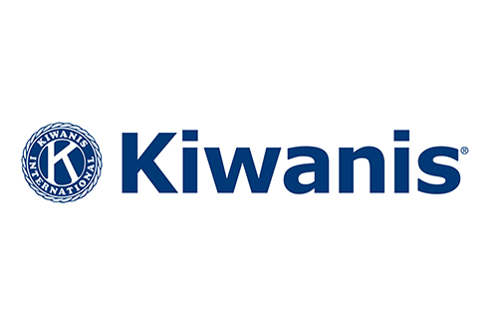
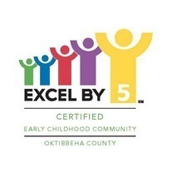
Name:___________________________________________________________________________________
Company:_______________________________________________________________________________
Email:___________________________________________________________________________________
Address (include zip code):_______________________________________________________________
_________________________________________________________________________________________Amount Enclosed:_______________________________________________________________________
Phone:__________________________________________________________________________________

Each team member can compete for a chance to win a 2019 Jeep Grand Cherokee and other prizes from Parker-McGill by making a “hole in one”
Kiwanis Club of Starkville
Benefiting “Excel By 5” Project in Starkville
Helping Children from Birth to 5 in Oktibbeha County
Hole/Team Sponsorship Form

MSU Golf Course
Saturday, July 27th, rain date: Saturday, August 3rd
8:00am Tee Time
Individual Sponsor* Team Sponsor** Silent Auction Sponsor***
$200 $450 Donations
*1 hole sponsorship **1 hole sponsorship plus one playing team *** Donations for silent auction or raffle are welcome: merchandise or gift cards for merchandise, meals, services, etc.
For more information contact: Richard Switzer, 662-615-1461 rdswitzer@bellsouth.net OR
Clay Taylor, 662-312-3069 clayandjoan@outlook.com
Registration deadline: Thursday, July 25th
Send check (payable to Kiwanis Club of Starkville) with form below to:
Richard Switzer, Kiwanis Golf, 83 Bell Oaks Drive, Starkville, MS 39759

