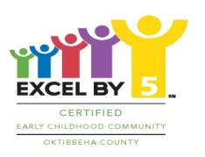

Kiwanis Club of Starkville

**4th Annual Golf Tournament**

**Hole/Team Sponsorship Form**

**MSU Golf Course**

**Saturday, July 28, rain date: Saturday, August 18**

Benefiting Excel By 5

**Individual Sponsor* Team Sponsor** Silent Auction Sponsor\*\*\***

$200 $450 Donations

*1 hole sponsorship;

**1 hole sponsorship plus one playing team

***Donations for a silent auction or raffle are welcome: Merchandise

or gift cards for merchandise, meals, services, etc.

**For more information contact: Richard Switzer, 662-615-1461** [**rdswitzer@bellsouth.net**](mailto:rdswitzer@bellsouth.net) **or Clay Taylor, 662-312-3069** [**clayandjoan@cspirehome.net**](mailto:clayandjoan@cspirehome.net)

**Send Check (payable to Kiwanis Club of Starkville) with form below to:**

**Richard Switzer, Kiwanis Golf, 83 Bell Oaks Drive, Starkville, MS 39759**

**Name:________________________________**

**Company:_____________________________**

**Address:______________________________**

**_____________________Zip______________**

**Email:________________________________**

**Phone:_______________________________**

**Amount Enclosed:______________________**

**Each team member can compete for a chance to win a 2018 Jeep Wrangler from Parker-McGill by making a “hole in one”.**