Do you want the children, ages 0-5, of McComb City to develop the foundation to read well, learn how to think, have healthy self-esteem and good nutritional habits and be better prepared for kindergarten and the first grade
If you answered yes to any of these, then please join us!

McComb City EXCEL By 5
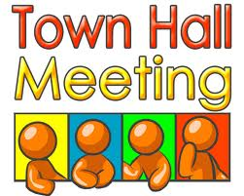

Thursday, February 16, 2012
6:00 pm – 8:00 pm
St. Andrews Senior Center
Main Street, Downtown McComb

FREE EVENT REFRESHMENTS

