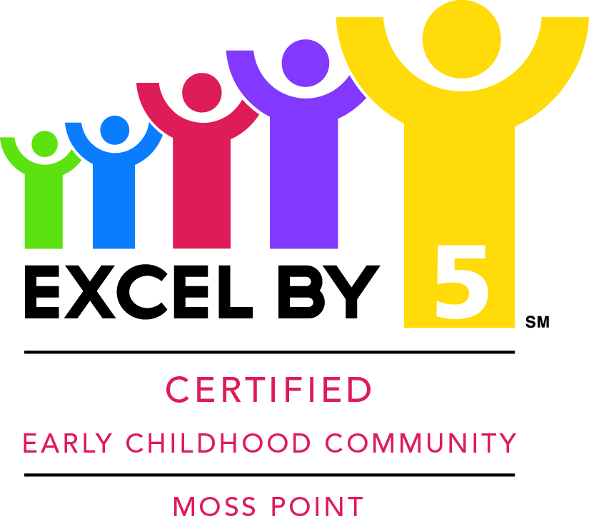

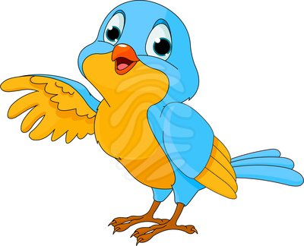
Invites Children Birth to Age Five to:
“Birds of Mississippi”
Reading Night

Tuesday November 18, 2014
6:00 p.m. -7:00 p.m.
Moss Point Family Education Center
3524 Prentiss Avenue, Moss Point, MS

Learn About:
- Bird watching
- Keeping birds safe
- Identifying birds
- And much more
Story Time

Refreshments will be served!
Art Activities

You Could Win Four Tickets to
Santa and Friends on Ice
at the Beau Rivage Showroom!
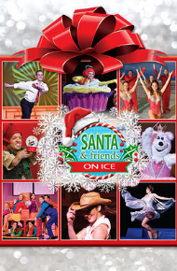
"Santa & Friends on Ice” is a fun-filled joyous journey into the Christmas holidays, guaranteed to delight audiences of all ages! Santa, Mrs. Claus and their helpers transform the Beau Rivage showroom into a glittering frozen winter pond made of REAL ICE. World class figure skaters, vocalists and actors will present a warm holiday storyline.

Thanks to our friends at Pilot Travel Centers for donating the tickets!

